**Test Cases**

| **Input** | **Expected Output** | **Actual** **Output** | **Pass?** |
| --- | --- | --- | --- |
| custid: 1 price: 10.0 quantity: 5  description: Blue Collar Shirt discount: .09 | ORDER DATA:  Customer ID: 1  Price: 10.0 Quantity: 5 Product Description: Blue Collar Shirt Discount: .09  Order Total BEFORE Discount: 50.0  Order Total AFTER Discount: 45.5 | ORDER DATA:  Customer ID: 1  Price: 10.0 Quantity: 5 Product Description: Blue Collar Shirt Discount: .09  Order Total BEFORE Discount: 50.0  Order Total AFTER Discount: 45.5 | YES |
| custid: 2 price: 20.0 quantity: 10 description: Long Lasting Milk discount: .06 | ORDER DATA:  Customer ID: 1  Price: 20.0 Quantity: 10 Product Description: Long Lasting Milk Discount: .06  Order Total BEFORE Discount: 200.0 Order Total AFTER Discount: 188.0 | ORDER DATA:  Customer ID: 1  Price: 20.0 Quantity: 10 Product Description: Long Lasting Milk Discount: .06  Order Total BEFORE Discount: 200.0 Order Total AFTER Discount: 188.0 | YES |
| custid: 3 price: 25.0 quantity: 15  description: Box of Cereals discount: .03 | ORDER DATA:  Customer ID: 3 Price: 25.0 Quantity: 15 Product Description: Box of Cereals Discount: .03  Order Total BEFORE Discount: 375.0  Order Total AFTER Discount: 363.75 | ORDER DATA:  Customer ID: 3 Price: 25.0 Quantity: 15 Product Description: Box of Cereals Discount: .03  Order Total BEFORE Discount: 375.0  Order Total AFTER Discount: 363.75 | YES |

**Screen Capture**

**Test Case 1:**

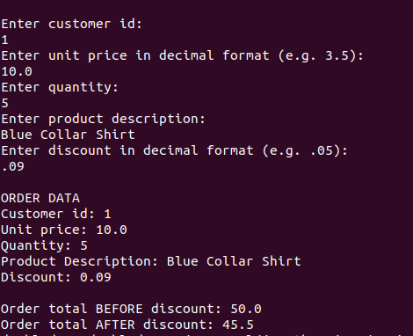

**Test Case 2:**

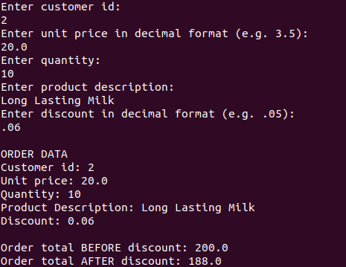

**Test Case 3:**

